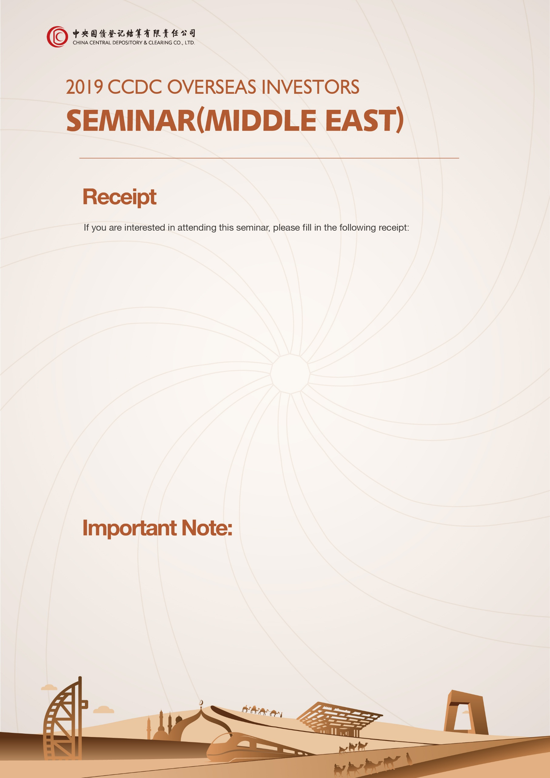

Name: |  | Company:
Department: |  | Title:
Tel.:
Email:

Name: |  | Company:
Department: |  | Title:
Tel.:
Email:

Information Sources:

- Please fill in the above receipt properly, and send it to marketing_sh@chinabond.com.cn by September 13th, 2019 (Fri.) for registration.
- Each company is advised to register for no more than 2 participants.
- Seats are limited, so specific registration results shall be subject to the Confirmation Letter from CCDC.
- For consultation, please call: +86-21-60813019 (Mr Yan , Shanghai Headquarters of CCDC)

